Common Versioning Strategies - Header Versioning

🌐 What is Header Versioning
# Source: AI Source: Provided by: [Data Path: Persons Table -> ID Column: 1, Name_En Column: Motasem Essam] -> From: [ChatGPT] on [1/19/2026]
Header Versioning specifies the API version in the HTTP request headers instead of the URL or query parameters.
👉 Think of it as telling the server which API version to use silently through headers, without changing the URL.

🔑 Key Points
# Source: AI Source: Provided by: [Data Path: Persons Table -> ID Column: 1, Name_En Column: Motasem Essam] -> From: [ChatGPT] on [1/19/2026]
- Version passed in a custom header – often Accept or a custom header like API-Version
- Keeps URLs clean – the version is not visible in the path
- Flexible for clients – different clients can request different versions on the same endpoint
- Backward compatibility – older clients continue to send older header versions

🧱 Example

Version 1
# Source: AI Source: Provided by: [Data Path: Persons Table -> ID Column: 1, Name_En Column: Motasem Essam] -> From: [ChatGPT] on [1/19/2026]
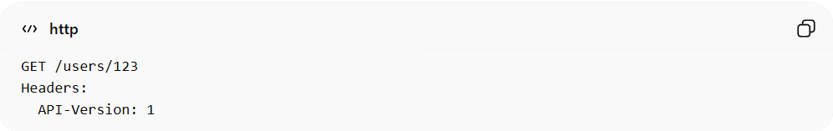
GET /users/123
Headers:
API-Version: 1
Response:
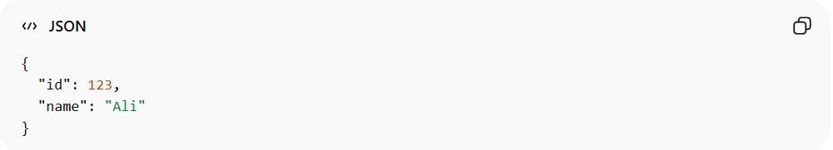
{
"id": 123,
"name": "Ali"
}

Version 2 (added email field)
# Source: AI Source: Provided by: [Data Path: Persons Table -> ID Column: 1, Name_En Column: Motasem Essam] -> From: [ChatGPT] on [1/19/2026]
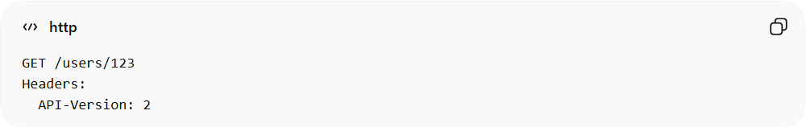
GET /users/123
Headers:
API-Version: 2
Response:
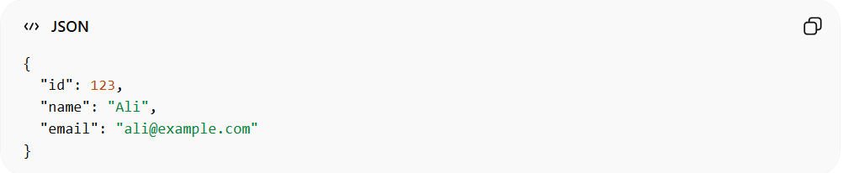
{
"id": 123,
"name": "Ali",
"email": "ali@example.com"
}
✅ Here:
- Header API-Version: 1 → old clients
- Header API-Version: 2 → new clients

✅ Advantages
# Source: AI Source: Provided by: [Data Path: Persons Table -> ID Column: 1, Name_En Column: Motasem Essam] -> From: [ChatGPT] on [1/19/2026]
- Keeps URLs clean and simple
- Easy to manage on the server-side routing
- Allows dynamic version negotiation

❌ Disadvantages
# Source: AI Source: Provided by: [Data Path: Persons Table -> ID Column: 1, Name_En Column: Motasem Essam] -> From: [ChatGPT] on [1/19/2026]
- Versioning is not visible in URL, harder to debug
- Some HTTP clients or browsers may not easily support custom headers

💡 Summary
# Source: AI Source: Provided by: [Data Path: Persons Table -> ID Column: 1, Name_En Column: Motasem Essam] -> From: [ChatGPT] on [1/19/2026]
Header Versioning allows clients to specify the API version through headers, keeping endpoints consistent while supporting multiple versions simultaneously.

